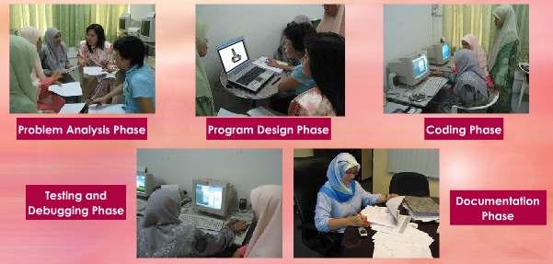
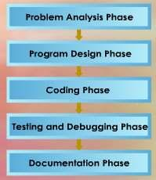
M. Amin, SMK Raja Shahriman

PROGRAM DEVELOPMENT

LESSON 13
OVERVIEW OF PROGRAM DEVELOPMENT PHASES

In program development, there are five main phases. These phases are a
series of steps that programmers undertake to build computer programs.
The program development phases guide computer programmers through the
development of a program.

The five main phases of program development are as follows:

35

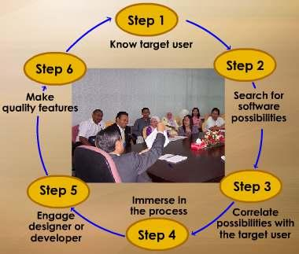

PROBLEM ANALYSIS PHASE
M. Amin, SMK Raja Shahriman

During the problem analysis phase, the programmer will interview the client
to find out what the client’s needs are.

For example, the client might be a school that wishes to set up a school
registration program. So the school administrator might tell the programmer
that they need to record students’ data such as name, date of birth, gender,
class, parents’ names, address and contact numbers.

PROGRAM DESIGN PHASE
Based on that, the programmer will design a flow chart that represents the
needs of the client, which in this case is the school registration program.

CODING PHASE
Once the flow chart is confirmed, the programmer will perform coding.

TESTING AND DEBUGGING PHASE
The school registration program will be tested by the users at the client’s
site. In this case, it will be the school office administrators. If there are any
errors, the programmer will do a debugging of the program.

DOCUMENTATION PHASE
After this, the programmer will complete the documentation for the
program; this includes the user manual, a clear layout of the input and
output records and a program listing.

EXT : SIX STEPS OF SOFTWARE DEVELOPMENT

Step 1
Know your target user.

The software we develop is
for our user. Learn their
preferences.

Step 2
Search for the exciting
possibilities in your software.

In this way, it is possible to
identify their likely concerns
and anxieties and thus take
them into account during the
design stage.

36

Step 3
M. Amin, SMK Raja Shahriman

Correlate these possibilities with the target user. Find how to combine these
possibilities with user personalities.

Step 4
Immerse yourself in the process. You have to be involved deeply in the
subject that you develop.

Step 5
Engage a talented and visionary designer or developer in the team. They are
responsible for all aspects of the software.

Step 6
Make quality and fantastic features as the priorities among software
development team members.The software should deliver the complete,
accurate, reliable and available information to the right person at the right
time in a suitable format.

LESSON 14
PROBLEM ANALYSIS

PROGRAM DESIGN

The first step in the program development phase is to analyse the problems
faced by target users. In this phase, a programmer reviews and defines the
problems. Identifies the data input, process and output for the program.

CASE STUDY

The school needs a school registration program to computerise the
registration of new students.

Any new student who enrolls in the school should have all his or her data
keyed into the school registration program. They will notified of his or her
class for the coming academic year or term.

This case study will be used throughout the program development phases.

In this case study, the programmer reviews and defines the problems faced
by the school administrators.
Increase of students make the
registration more and more

the problem
difficult.

37

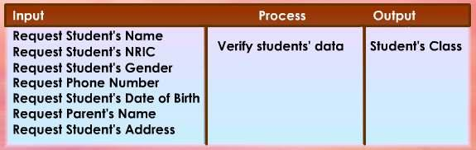
M. Amin, SMK Raja Shahriman

The school enrolment has increased so much that it has become very
difficult for them to perform student registration without the help of a
computer program or system.
Registration must be made by
using the computer.
the solution

The programmer must indicate the purpose of the program before
continuing to the next task.
Purpose of the school
the purpose

registration program is to
computerise the registration of
new students.

In this case, the purpose of the school registration program is to
computerise the registration of new students.

In this situation, the programmer identifies the data input, process and
output for the program.

First step: The programmer identifies the data input, for example student’s
name, student’s NRIC, gender, telephone number, date of birth, parents’
name and address.

Second step: The programmer identifies the process for the program. Any
new student who enrolls in the school should have all his or her data keyed
into the school's registration program.

38

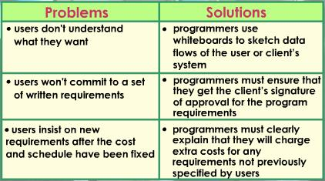
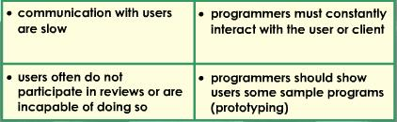
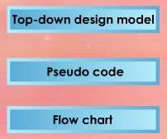

PROBLEMS AND SOLUTIONS
M. Amin, SMK Raja Shahriman

In program development, the target user and programmers will face some
problems. Here are some common problems faced by them, and solutions to
overcome them.

LESSON 15
PROGRAM DESIGN

Many inventions today are driven by

computer programs. To develop good
programs, program design is a very
important phase.

PROGRAM DESIGN PHASE

In program design,
there are three
popular tools used,
namely the top-down
design model, pseudo
code and flow chart.

39
Case Study

The school needs a school registration
program to computerise the registration
of new students.

Any new student who enrolls in the
school should have all his or her data
keyed into the school registration
program. They will notified of his or
her class for the coming academic
year or term.

This case study will be used throughout
the program development phases.

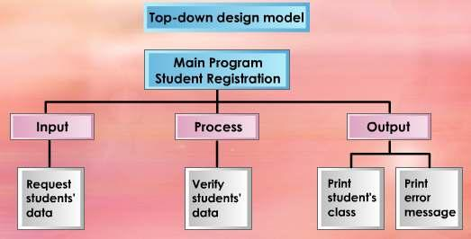
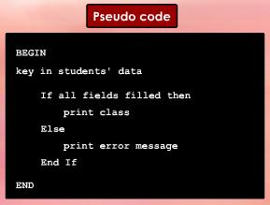
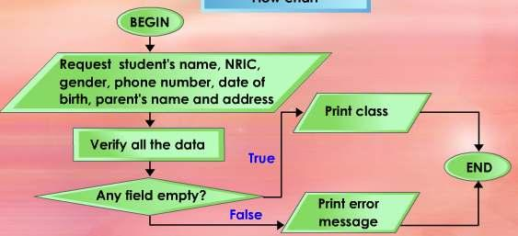
M. Amin, SMK Raja Shahriman

In this case study, the programmer generates a top-down design model.

This top-down model consists of three modules, namely input module,
process module and output module.

Then the programmer writes the
pseudo code for the program
based on the top-down design
model.

Next, the programmer draws the flow chart that shows the data flow of the
program.

40
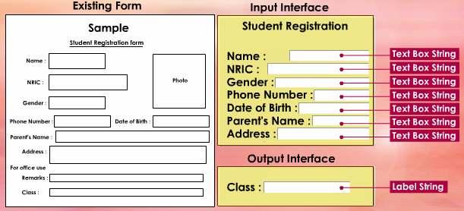
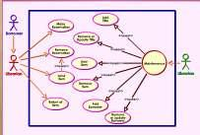
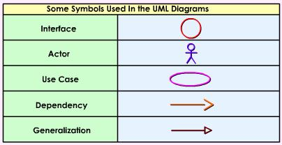
M. Amin, SMK Raja Shahriman

Besides flow chart, a programmer also produces input and output user
interfaces base on the existing form.

EXT : UNIFIED MODELING LANGUAGE

Unified Modeling Language (UML) has
been adopted as a standard notation for
object modeling and development.

These notations are used in diagrams
that present various views of the
program being developed.

These are some symbols used in Unified Modeling Language Diagrams.

41

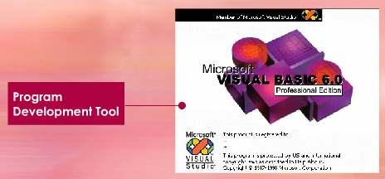
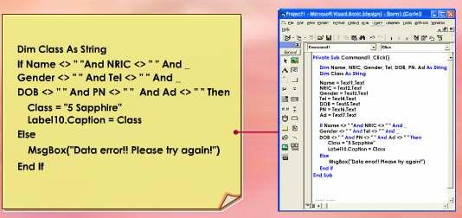
LESSON 16
CODING
M. Amin, SMK Raja Shahriman

The process of writing instructions or code for computers is known as
coding. Hence without coding, there would be no software to help us
perform useful tasks on computers.

CODING

In this phase, a programmer uses a program development tool which
generates or provides some or all codes.

Coding is the process of writing the solution using the computer
programming language. After finishing the coding process, the programmer
will type the programming language code into the computer.

42

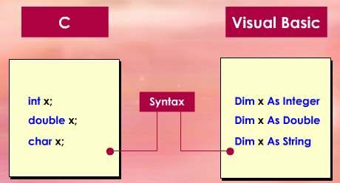
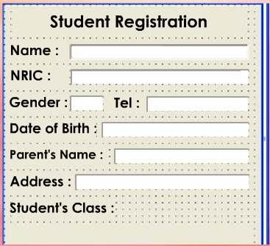
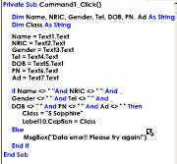
PROGRAMMING LANGUAGE
M. Amin, SMK Raja Shahriman

There are many different programming languages in the market. Examples
of the popular programming languages used in Malaysian secondary schools
are Visual Basic and C language.

Each of these programming languages has its own particular syntax.

CASE STUDY

43

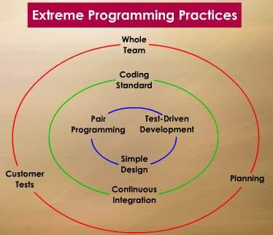
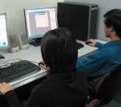
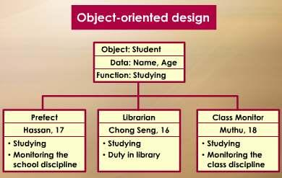
EXT : EXTREME PROGRAMMING
M. Amin, SMK Raja Shahriman

Extreme programming is a strategy that proposes that a programmer should
immediately begin coding and testing solution as soon as requirements are
defined. The code is continually tested and refined until it works.

Extreme programming also suggests that
programmers work in pairs.

They communicate with each other to generate ideas
for proper solutions.

IT experts claim that extreme programming reduces the time required for
the program development phases.

Extreme programming most often is used in object-oriented design.

44

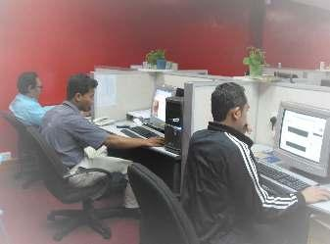
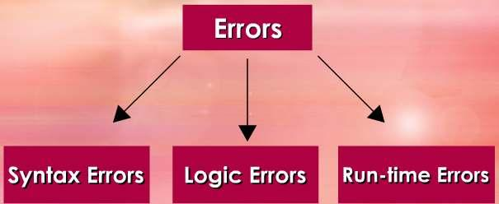
LESSON 17
TESTING AND DEBUGGING

For computers to perform their tasks
smoothly, the software or program
must be error-free.

Imagine doing an important assignment
on the computer. Suddenly, there is a
program error and you are unable to
complete your work and meet the
deadline.
M. Amin, SMK Raja Shahriman

That is why before any software is released to the market or given to the
users, it must undergo testing and debugging. Program testing is done right
after coding. The purpose of program testing is to ensure the program runs
correctly without any syntax or logic errors.

If errors are uncovered during testing, the programmer will proceed to
debugging. Debugging involves tracing the source of errors in the program
and making the necessary corrections.

After correcting the errors, it is normal for programmers to test run the
program again just to make sure that the errors have been properly fixed.

TESTING AND DEBUGGING

Once the programmer has finished the coding, the next step is to test it.

The purpose of program testing is to ensure the program runs correctly and
is error-free.

There are three types of errors uncovered during this phase: syntax errors,
logic errors and run-time errors.

45

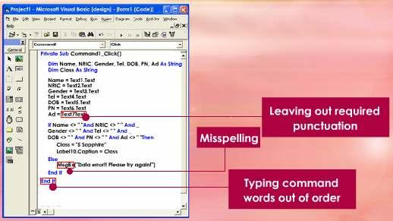
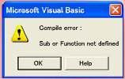

SYNTAX ERROR
M. Amin, SMK Raja Shahriman

When the code violates the syntax of the programming language, a syntax
error occurs.

A syntax error is caused by a wrong spelling in command and declaration.
Other syntax errors include case sensitive, punctuation and wrong word
command.

They either show up as you type the program code, or if you have turned off
the automatic syntax error check, the syntax errors show up when you try to
run or compile the program.

When syntax error is located, a message is displayed on the screen.

The programmer must review and correct all syntax errors.

46

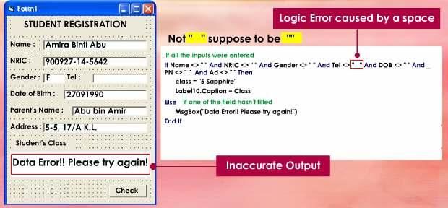
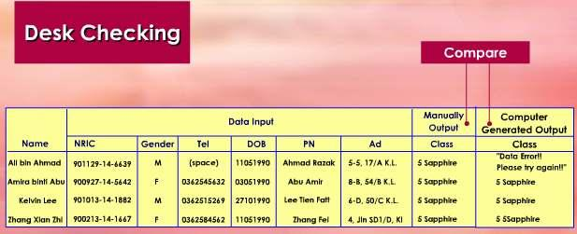

LOGIC ERROR
M. Amin, SMK Raja Shahriman

If the expected output and actual output do not match for any set of data,
the program has a logic error.

A logic error is an error in the design that causes inaccurate outputs.

We can use desk check technique to test logic errors. There are 3 steps to
perform desk checking.

First, create a set of test data that includes input and output data.

Second, use the test data to test the coding and record the result.

Lastly, compare the manual results with the computer generated results.

47

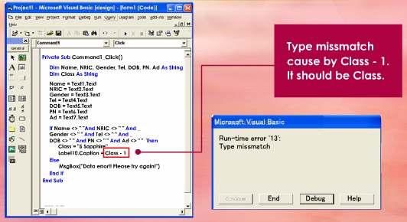
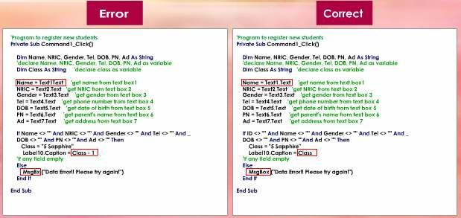
RUN-TIME ERROR
M. Amin, SMK Raja Shahriman

Run-time error is an error that occurs while the program is running or
executing.

A run-time error may cause the program to stop running.

DEBUGGING

The process of locating and correcting of syntax and logic errors in a
program is known as debugging the program.

The program errors themselves are called bugs. Thus removing the errors
are called debugging.

48

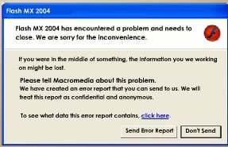

EXT : BETA
M. Amin, SMK Raja Shahriman

Some software companies distribute a beta version of their software to
users. A beta version is a program that has most or all of its features and
functionality implemented.

Users test the beta program and send in
bug reports to the software company.

This enables the software manufacturer
to fix any errors before the software is
released to the public for sale.

LESSON 18
DOCUMENTATION

In program development,
documentation refers to the written
material generated throughout all the
phases of program development.

Thus documentation includes the
detailed problem definition, the
program plan (flow chart or pseudo
code), comments within the source
program and testing procedures.

It also includes a detailed description of the program, clear layouts of input
and output records and a program listing.

All documentation must be ready by the end of program development.

The programmer should ensure that all documentation is complete and
accurate.

Documentation is very valuable if the program requires changes in the
future as documentation enables new programmers to learn about existing
programs much easily and quickly.

49

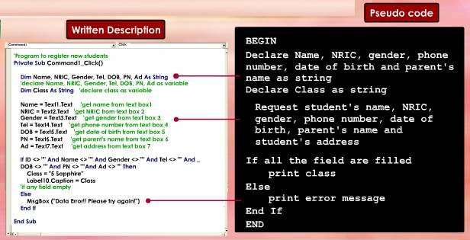
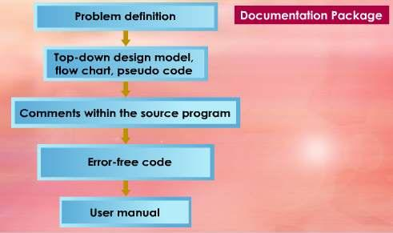
DOCUMENTATION
M. Amin, SMK Raja Shahriman

Documentation refers to the written description and pseudo code of
computer programs.

Although documentation is stated as the last phase in program
development, it is actually performed throughout all the five main phases of
program development.

Documentation consists of materials generated during each phase.

Thus the documentation package is made up of the detailed problem
definition, the program plan (flow chart or pseudo code), comments within
the source program and testing procedures.

Other items in the documentation package also include a detailed description
of the program, clear layouts of input and output records, and a program
listing.

50

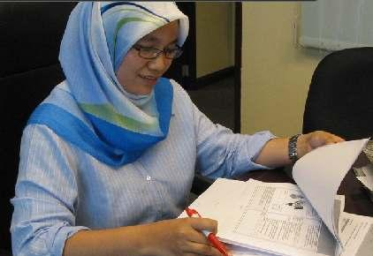
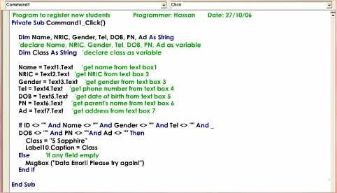
M. Amin, SMK Raja Shahriman

The programmer should ensure that
all documentation is complete and
accurate.

Documentation becomes especially
valuable when the program requires
changes in the future.

Proper documentation greatly
reduces the amount of time a new
programmer spends in learning
about the existing programs.

INTERNAL DOCUMENTATION

Internal documentation consists of comments within the program. These two
types of comments are global comments and internal comments.

Global
comment

Internel
comment

Global comments, usually stated at the top of the program, explain the
program’s purpose and identify the program’s name, its author and the date
the program was written.

Internal comments, which appear throughout the body of the program,
explain the purpose of the code statements within the program.

Internal comments are mostly addressed to other programmers who may
have to make corrections or other modifications in programming language.

51


M. Amin, SMK Raja Shahriman

EXT : MARKETING DOCUMENTATION

It is important to provide some informative materials that enable people to
learn more about the software product.

This form of documentation, called marketing documentation, has three
purposes.

1. To interest potential users with the product
and encourage them to get more involved.

2. To inform potential users about the product
so that they know what to expect in return.

3. To compare the product with other
alternatives.

LESSON 19
COMPUTER USERS

DEVELOP A PROGRAM

A project is a set of activities with a fixed start date and end date. Program
development is also a type of project.

A successful program development project will result in one or more
programs that are error-free, affordable, relevant to the needs of the users
and delivered on time.

All the software that you find so helpful, educational and enjoyable today is
the outcome of successful program development projects

For a program development project to succeed, the people involved must
possess the appropriate set of communication, management and technical
skills.

APPLY PROGRAM DEVELOPMENT PHASES TO SOLVE
PROBLEMS

52
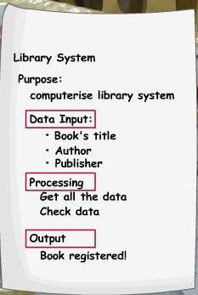
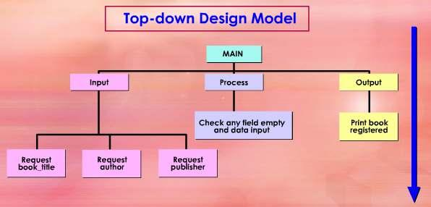
M. Amin, SMK Raja Shahriman

Let’s see how a programmer applies program development phases to solve
the library problems.

Problem Analysis Phase
identifies the data input, processing and output
for the program

Program Design Phase

53
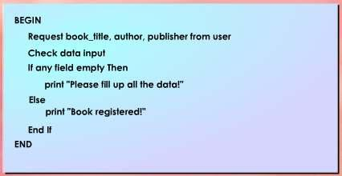
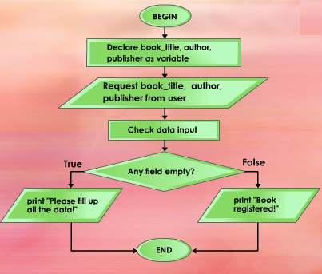
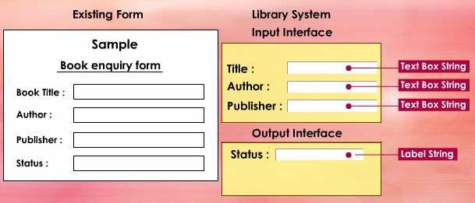
Pseudo code

Flow Chart

54
M. Amin, SMK Raja Shahriman
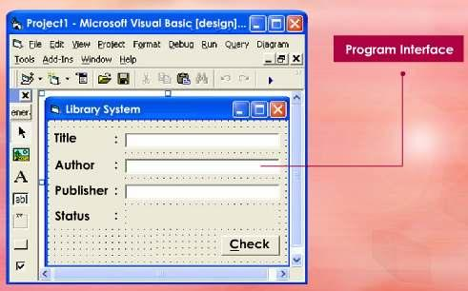
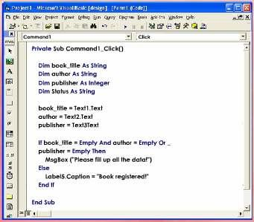
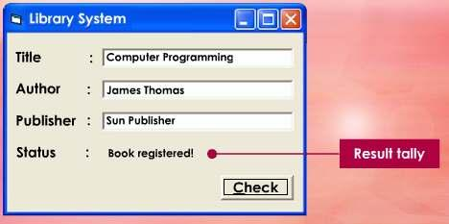
Coding Phase

Testing and Debugging Phase

55
M. Amin, SMK Raja Shahriman

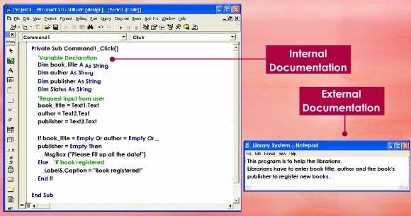

Documentation Phase

EXT : TIPS AND TECHNIQUES
M. Amin, SMK Raja Shahriman

Let’s learn a few tips and techniques on developing a new program using
Microsoft Visual Basic 6.0.

In Microsoft Visual Basic 6.0, undeclared variable will be assigned as
variant type. Variant type is slow, consuming more memory than the
others.

Every procedure and module should have comments explaining their
function. It will be easier for you to maintain the code later.

Use descriptive words for your variables and control. It will be easier
for other people to understand the program if you use this technique.

When using graphic, use *.gif, *.jpg, and *.wmf picture formats
instead of *.bmp. Bitmaps format consume more memory and may
slow your program down.

If you have some code which is repeatedly used, code it as
independent module or function so that you can easily reuse them
later.

56


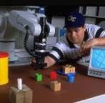

LESSON 20
M. Amin, SMK Raja Shahriman

OVERVIEW OF THE LATEST TYPE OF PROGRAMMING
LANGUAGES

THE LATEST TYPE OF PROGRAMMING LANGUAGES

.

FIFTH GENERATION LANGUAGES

Fifth generation programming language (5GL) is
an advance programming language which
concentrates on solving problems using constraints
given to the program.

In fifth generation language, the programmer just
need to define the problem to be solve and the
program will automatically code the program
based on the problem definition.

Fifth generation languages are designed to make the computer solve the
problem for you.

Fifth generation languages are mostly used in artificial intelligence research.

Examples of fifth generation languages include Prolog and Mercury.

NATURAL LANGUAGE

Natural Language programming aims to use natural language such as
English to write a program.

Instead of using a specific programming language syntax, natural language
programming will use normal English as the input to program software.

Such a technique would mean less technical programming knowledge
is required to write a program.

57

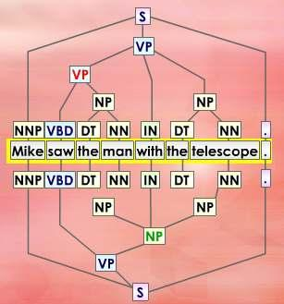

M. Amin, SMK Raja Shahriman

The programmer needs to define the program using normal language.

OPENGL (GRAPHIC LIBRARY)

OpenGL (Graphics Library) is a standard specification to describe the
standard Application Programming Interface (API) for 3D/2D computer
graphic applications.

OpenGL specification describes a set of functions and the exact behaviours
that the 3D/2D application must perform.

OpenGL was developed by Silicon Graphics.

OpenGL is widely used in virtual reality, scientific visualisation, flight
simulation and video game development.

58
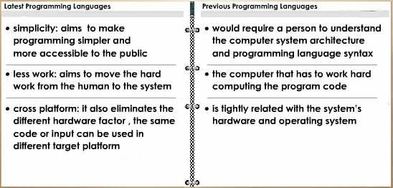
M. Amin, SMK Raja Shahriman

EXT : THE LATEST PROGRAMMING LANGUAGES:
CAPABILITIES & DIFFERENCES

What can the latest programming languages do? How are they different from
the previous or past programming languages?

59

